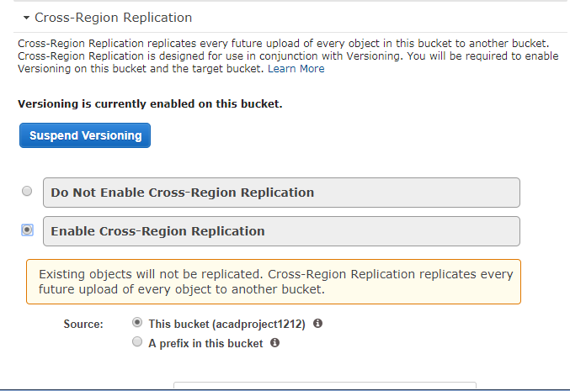

To enable the cross-region replication, first you have to enable versioning. Select the enable cross region replication.

Source is nothing but from which bucket we are performing the replication i.e source bucket.

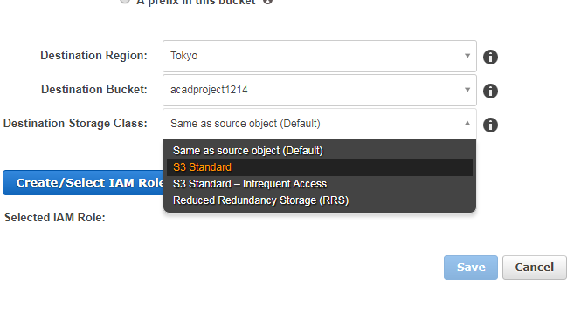

We have to create a new bucket to do the cross replication. So that will be the destination bucket. Provide all the details of that bucket as shown above image.

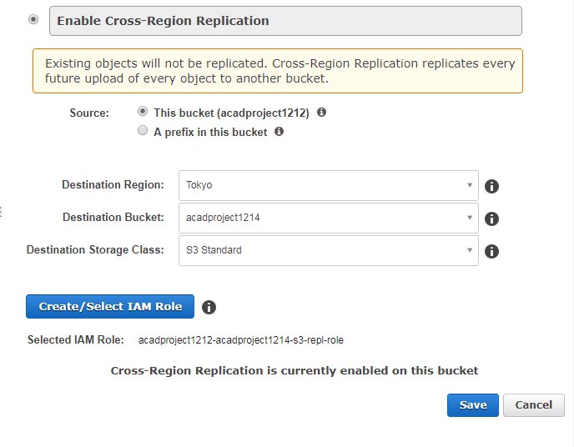

After click on create/select IAM role, then it will ask the permission then click on allow button. then it will select the iam role as shown in above image. Then click on save.

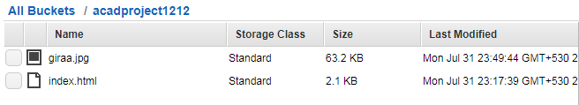

Here we can see that,we were uploaded one image in source bucket. So we can see that image updated in the new destination bucket(giraa.jpg).

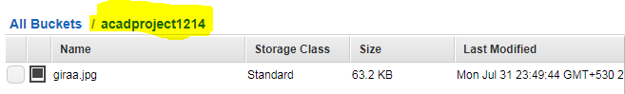

The important point is destination bucket not replicates the all objects from source bucket. It will only replicates the updated object in the source bucket.